

ELEC-6851: **INTRODUCTION TO TELECOMMUNICATION NETWORKS**

QualNet Project Phase-III

Final Project Report Submission

Date of Submission- 15th April, 2020.

Work Submitted by:

Nag Prudhvi Lanka (40164553)

Himani (40165484)

Work Submitted to:

**Professor Dongyu Qiu**

Department of Electrical and Computer Engineering

**ABSTRACT**

This report is regarding the explanation of Wireless Networks by building and simulating them as per the requirements mentioned in the project description, which include the usage of the **QualNet Software**. It is required to create four **subnets** named A, B, C, D each containing a **minimum of 5 nodes** placed randomly and each subnetwork connected with a router. IP forwarding turned off for every node except the routers. The final results are represented in the form of Bar-Charts and tables.

This project deals with two Scenarios: Scenario A & Scenario B, in which **Scenario A only deals with Non-fading** whereas **Scenario B has to be dealt with both the fading and Non-fading.** Results are obtained by simulations and Performance is observed.

**INTRODUCTION**

With a rapid increase and development in the field of telecom, **the course telecommunications are in demand all over the world**. Both the Research and Development field is increasing in leaps and bounds as the tech available today becomes outdated tomorrow. Telecommunication networks are the ones that keep us bound together, with the enhanced flexibility it changed how people can communicate. Essentially the Wireless communication network. To make this wireless network easy and reliable a simulation software called “QualNet” which is easy to operate and provide experimentation at very less cost and low-risk environments has been designed. This software act as planning, testing, and training tool which can predict the performance and its outputs and can show the graphical output of the following designs.

**To solve this project, two networking scenarios are designed**

**Scenario A:** It **deals with the four wireless subnets A, B, C, D which generate both UDP and TCP** in the Application layer and Transport Layer. It also deals with the MAC layer.

**Scenario B:** It **deals with the multiple UDP protocols** with complicated wireless networks to be built

**SCENARIO A**

The given scenario simulation contains the following info:

1. **Four wireless subnetworks named as A, B, C, D** each attached with at least five nodes which should be randomly placed.
2. All the nodes located in the same subnetwork will be able to hear each other’s transmissions.
3. The neighbouring subnetworks should be connected through the help of routers in the following manner A⬄B, B⬄C, C⬄D.
4. Should use only IEEE 802.11 as the MAC protocol & IPv4 as the network protocol.
5. Both TCP and UDP connection should be given.
6. Node 3 in subnet A and Node 17 in subnet D are connected through an UDP connection
7. Node 8 in subnet B and Node 11 in subnet C are connected through a TCP connection
8. Node 21 acts as a router between subnet A&B
9. Node 22 acts as a router between subnets B&C
10. Node 23 acts as a router between subnets C&D

**Network Model:**

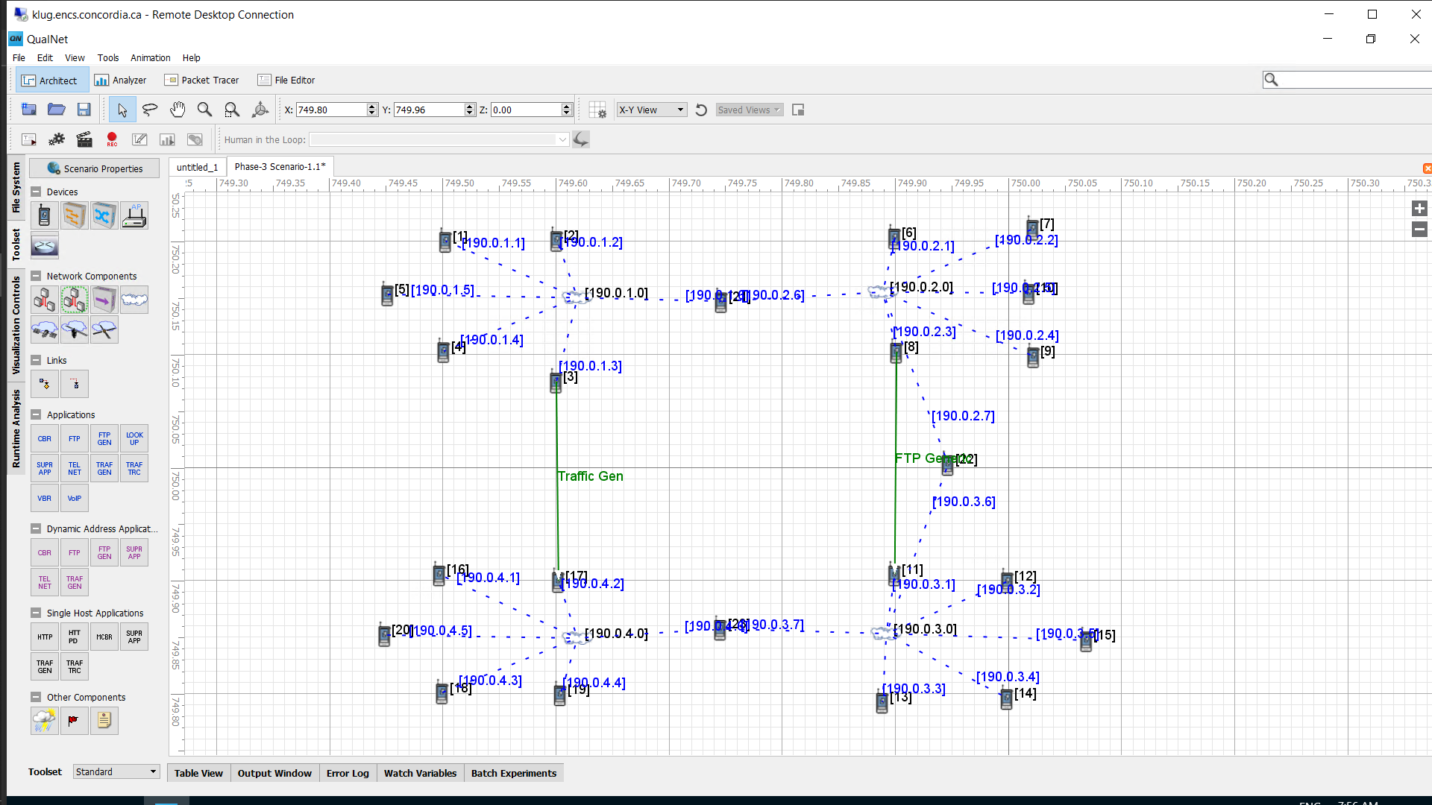

Fig 1: Network Model for Scenario A

|  |  |  |  |  |  |  |  |  |  |
| --- | --- | --- | --- | --- | --- | --- | --- | --- | --- |
| Subnet A | | Subnet B | | Subnet C | | Subnet D | | Routers | |
| Nodes | IP address | Nodes | IP address | Nodes | IP address | Nodes | IP address | Nodes | IP address |
| 1 | 190.0.1.1 | 6 | 190.0.2.1 | 11 | 190.0.3.1 | 16 | 190.0.4.1 | 21 | 190.0.1.6 |
| 2 | 190.0.1.2 | 7 | 190.0.2.2 | 12 | 190.0.3.2 | 17 | 190.0.4.2 | 21 | 190.0.2.6 |
| 3 | 190.0.1.3 | 8 | 190.0.2.3 | 13 | 190.0.3.3 | 18 | 190.0.4.3 | 22 | 190.0.2.7 |
| 4 | 190.0.1.4 | 9 | 190.0.2.4 | 14 | 190.0.3.4 | 19 | 190.0.4.4 | 22 | 190.0.3.6 |
| 5 | 190.0.1.5 | 10 | 190.0.2.5 | 15 | 190.0.3.5 | 20 | 190.0.4.5 | 23 | 190.0.3.7 |
|  |  |  |  |  |  |  |  | 23 | 190.0.4.6 |

Table 1: IP addresses of Subnets and Routers

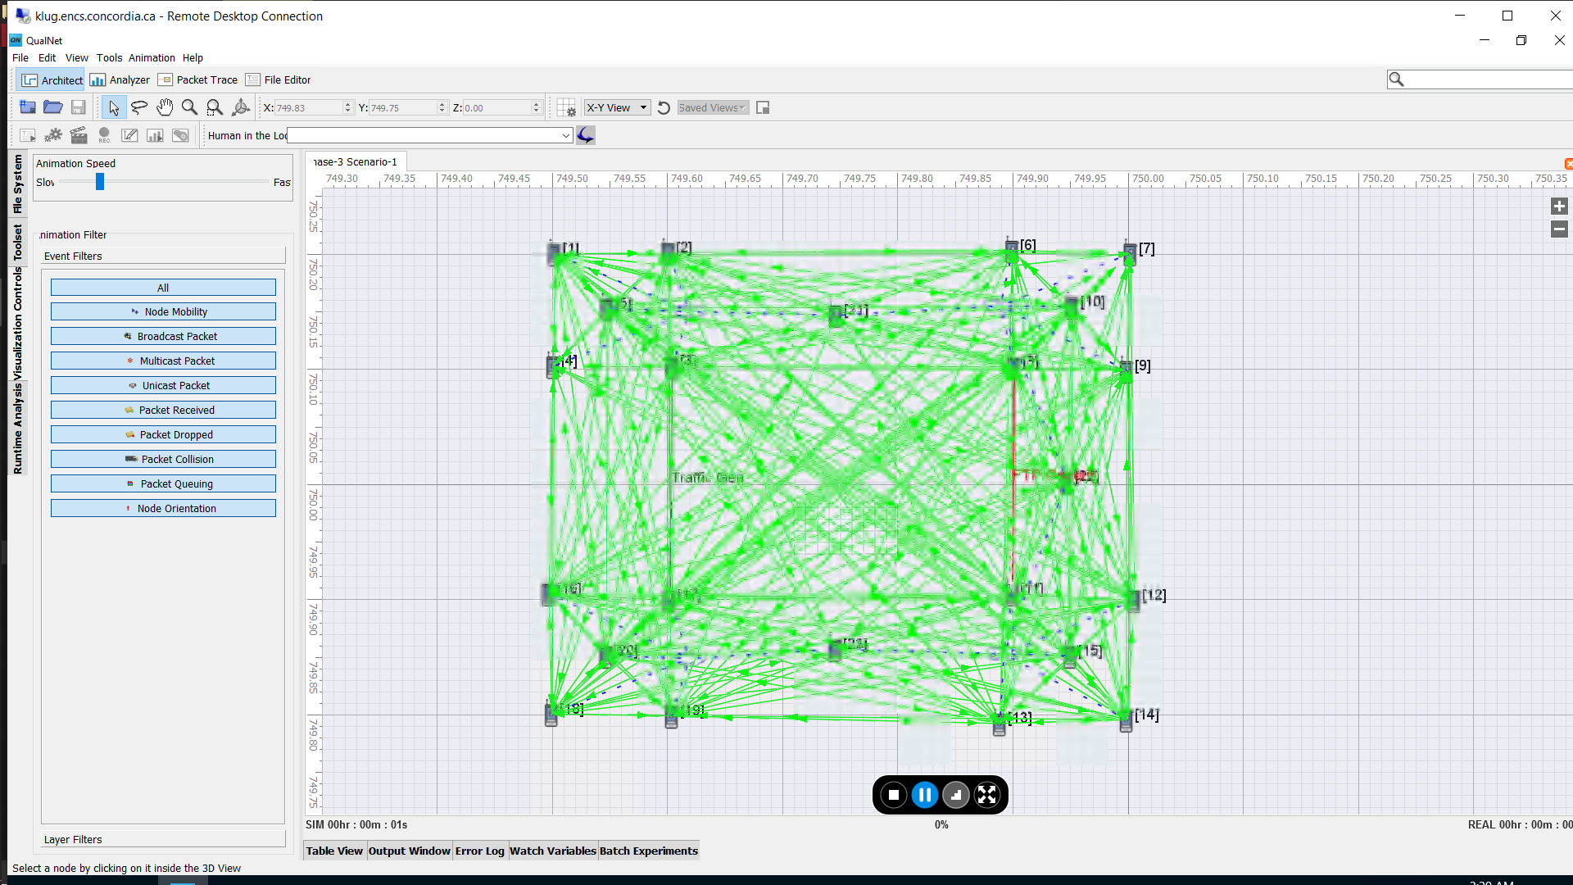

Fig 2: Network Simulation of Scenario A

**Simulation Results**:

* Application Layer:

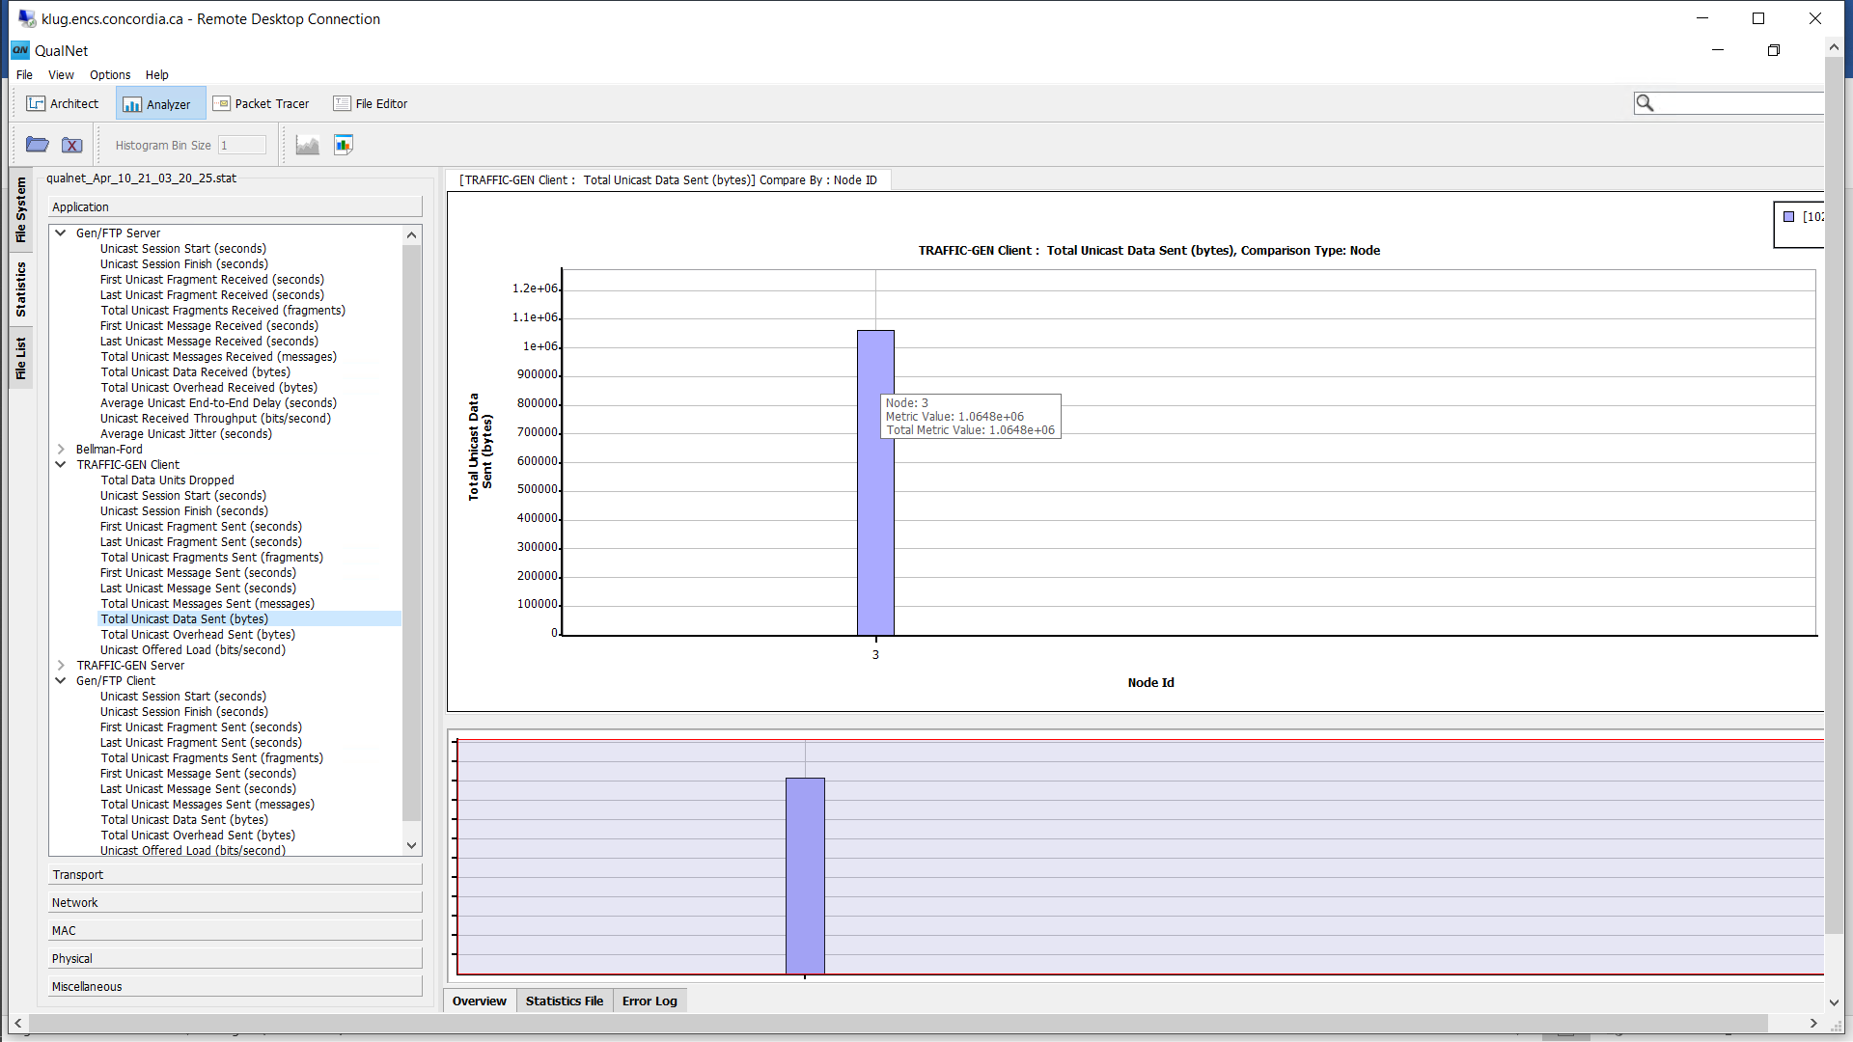

Fig 3: Traffic Client – Data units Sent

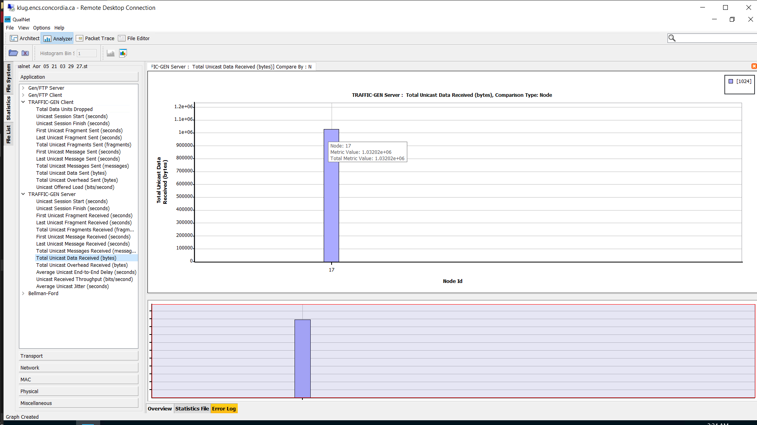

Fig 4: Traffic Server – Data units received

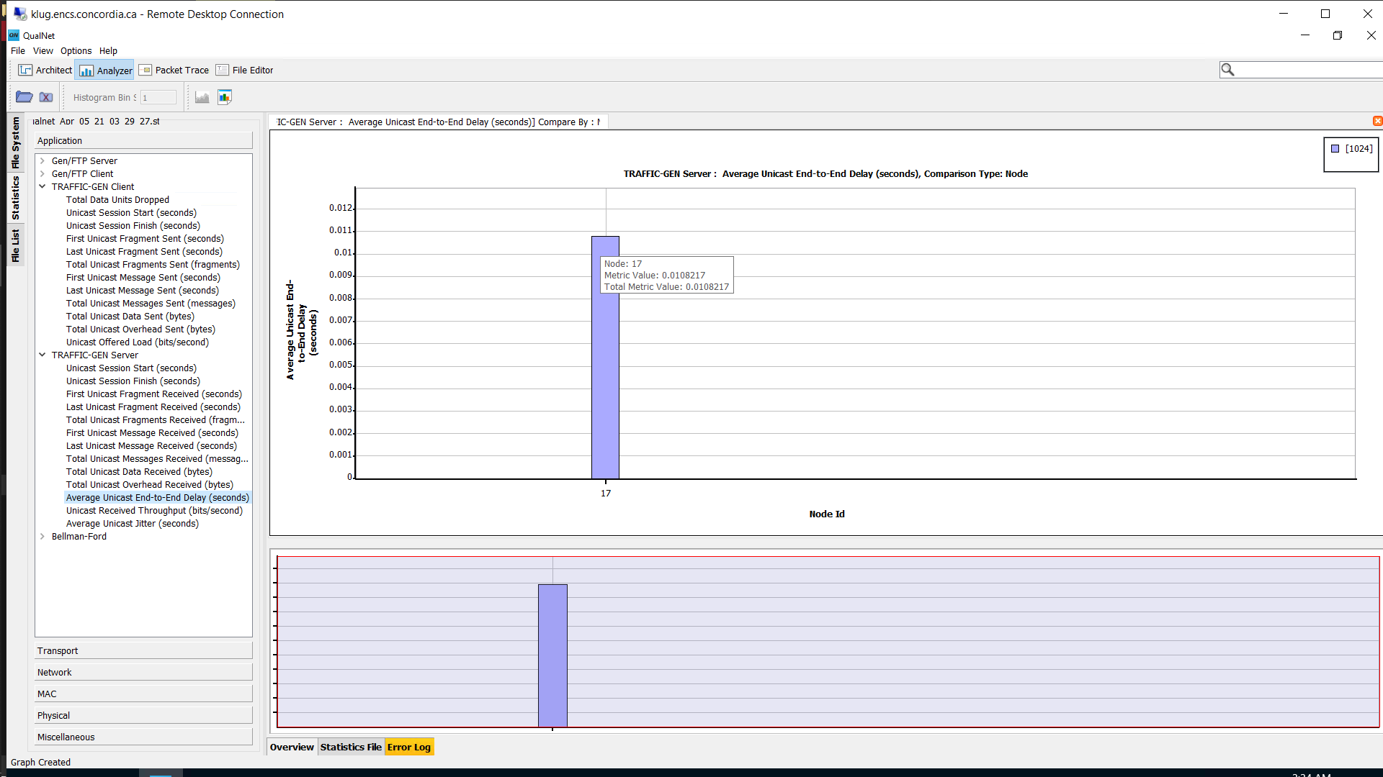

Fig 5: Average End-to-End delay

TCP:

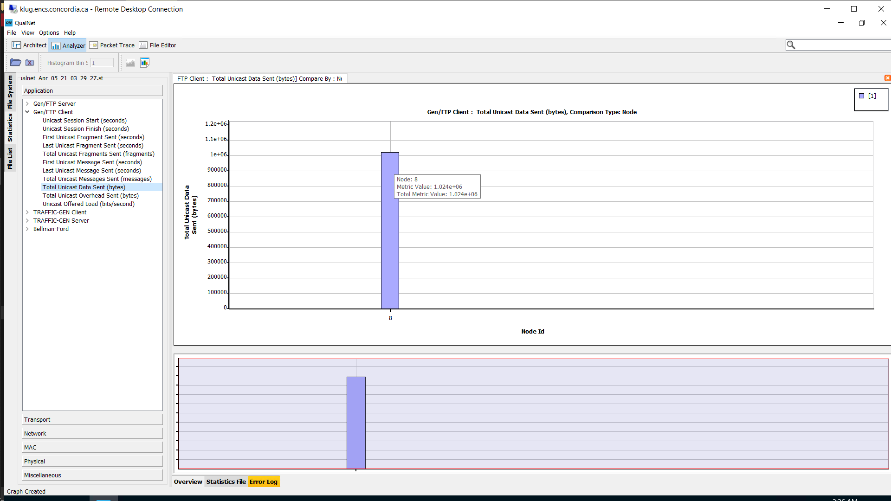

Fig 6: TCP client – total bytes sent

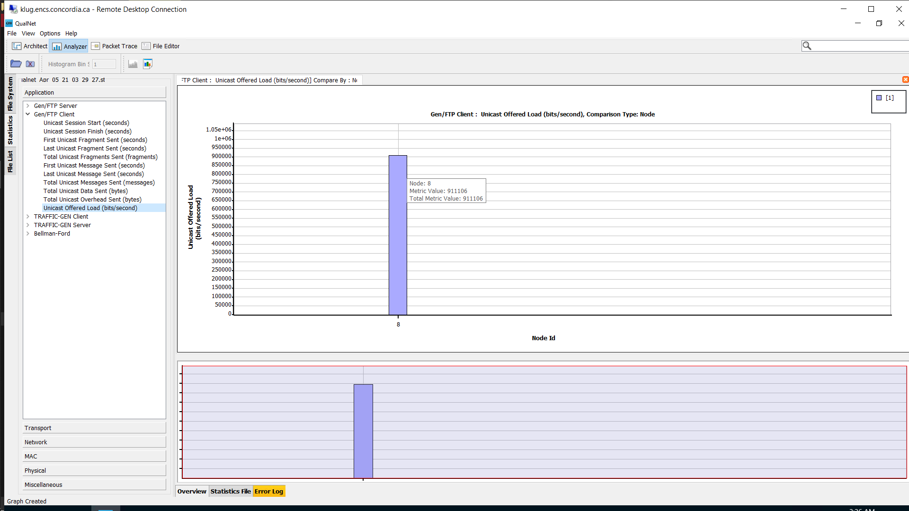

Fig 7: TCP client – throughput (bits/sec)

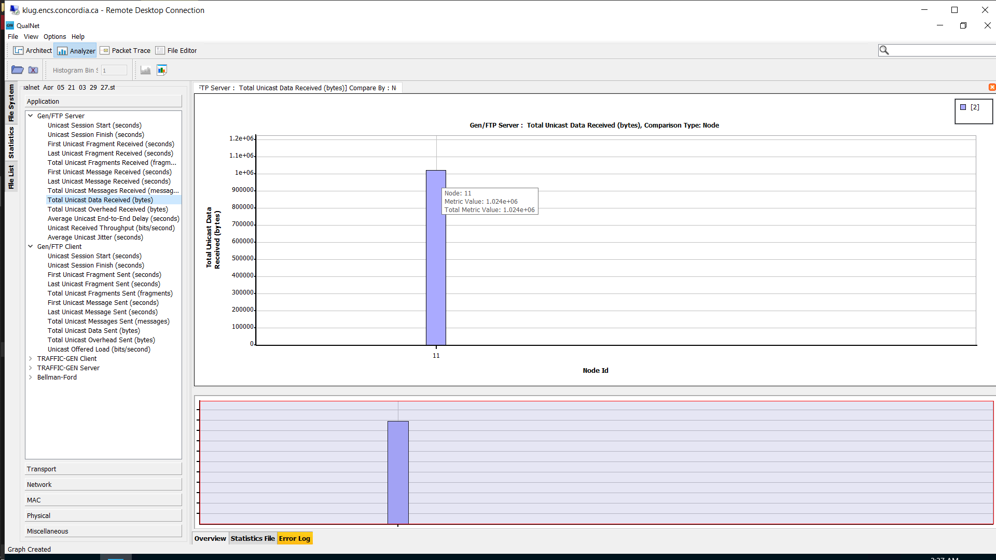

Fig 8: TCP server – total bytes received

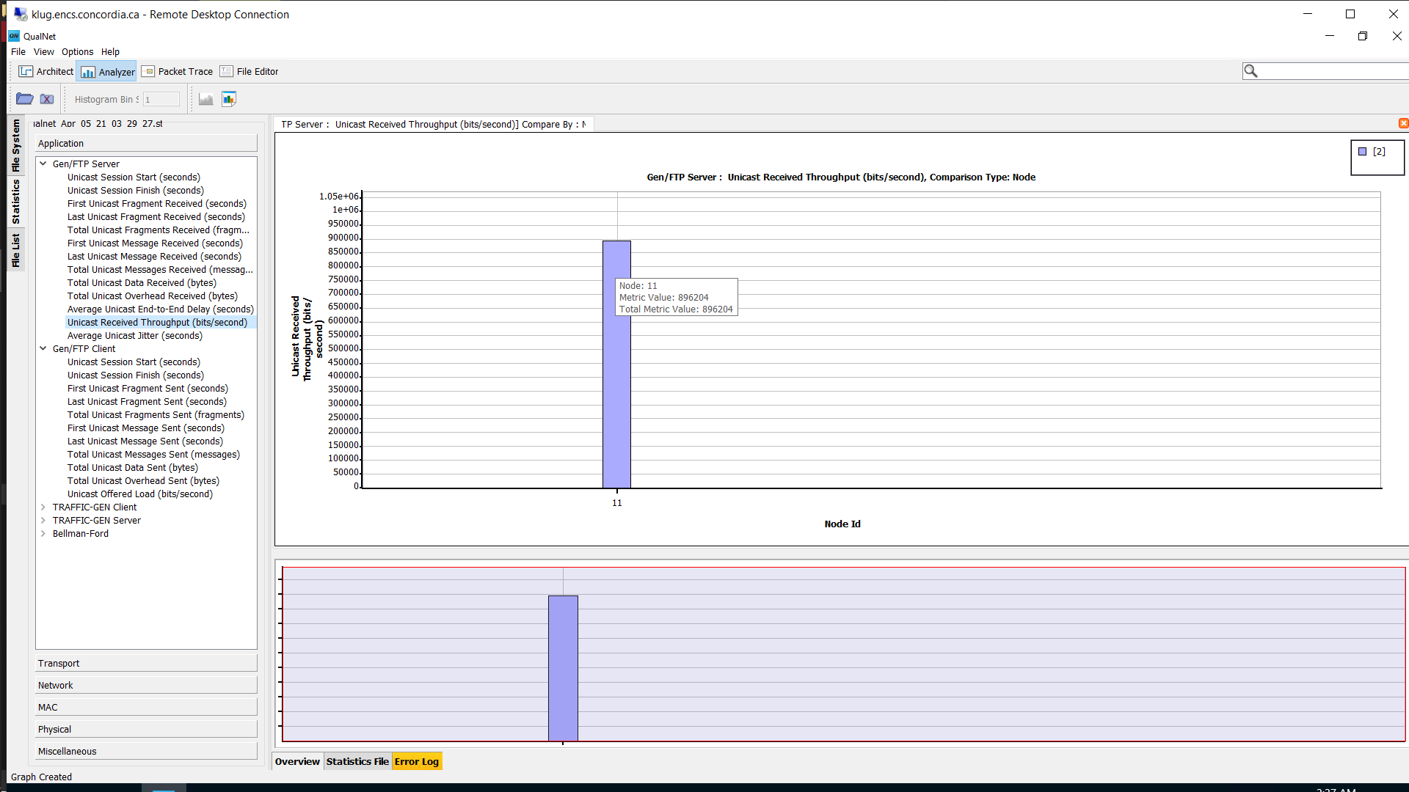

Fig 9: TCP server- Throughput (bits/sec)

Conclusion:

The **UDP is used to communicate at a rapid rate and even the packet loss is also affordable** and the ‘Average End-to-End delay’ is 0.01084 which is comparatively very less.

Examples: Online streaming of movies, VoIP (Voice over IP), Online multiplayer games etc.

* Transport Layer:

UDP:

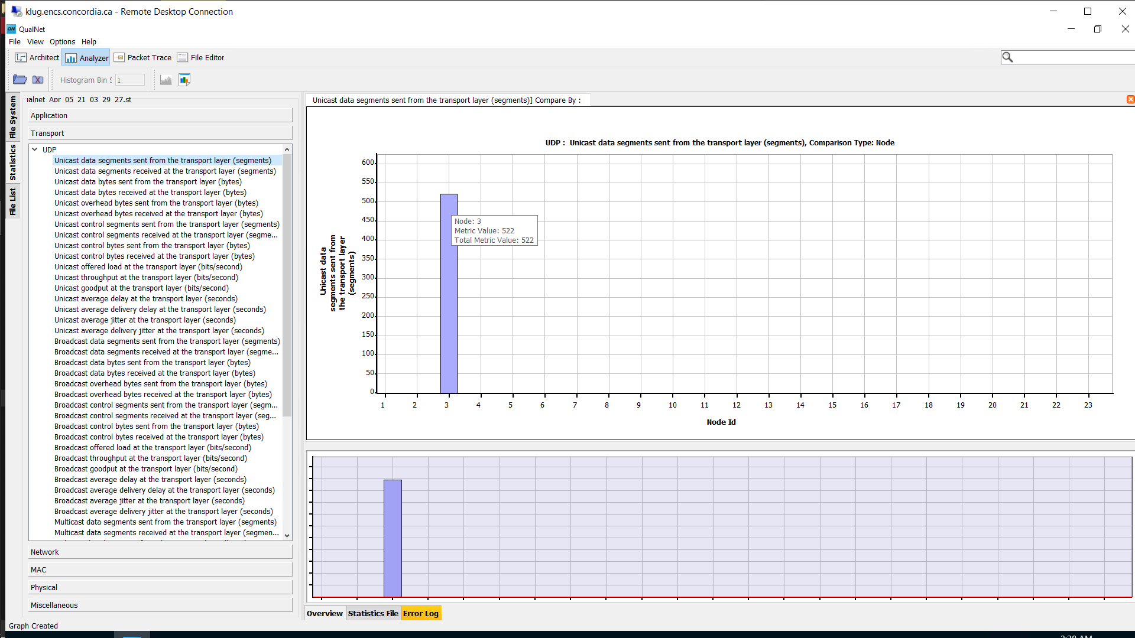

Fig 7: UDP packets from application

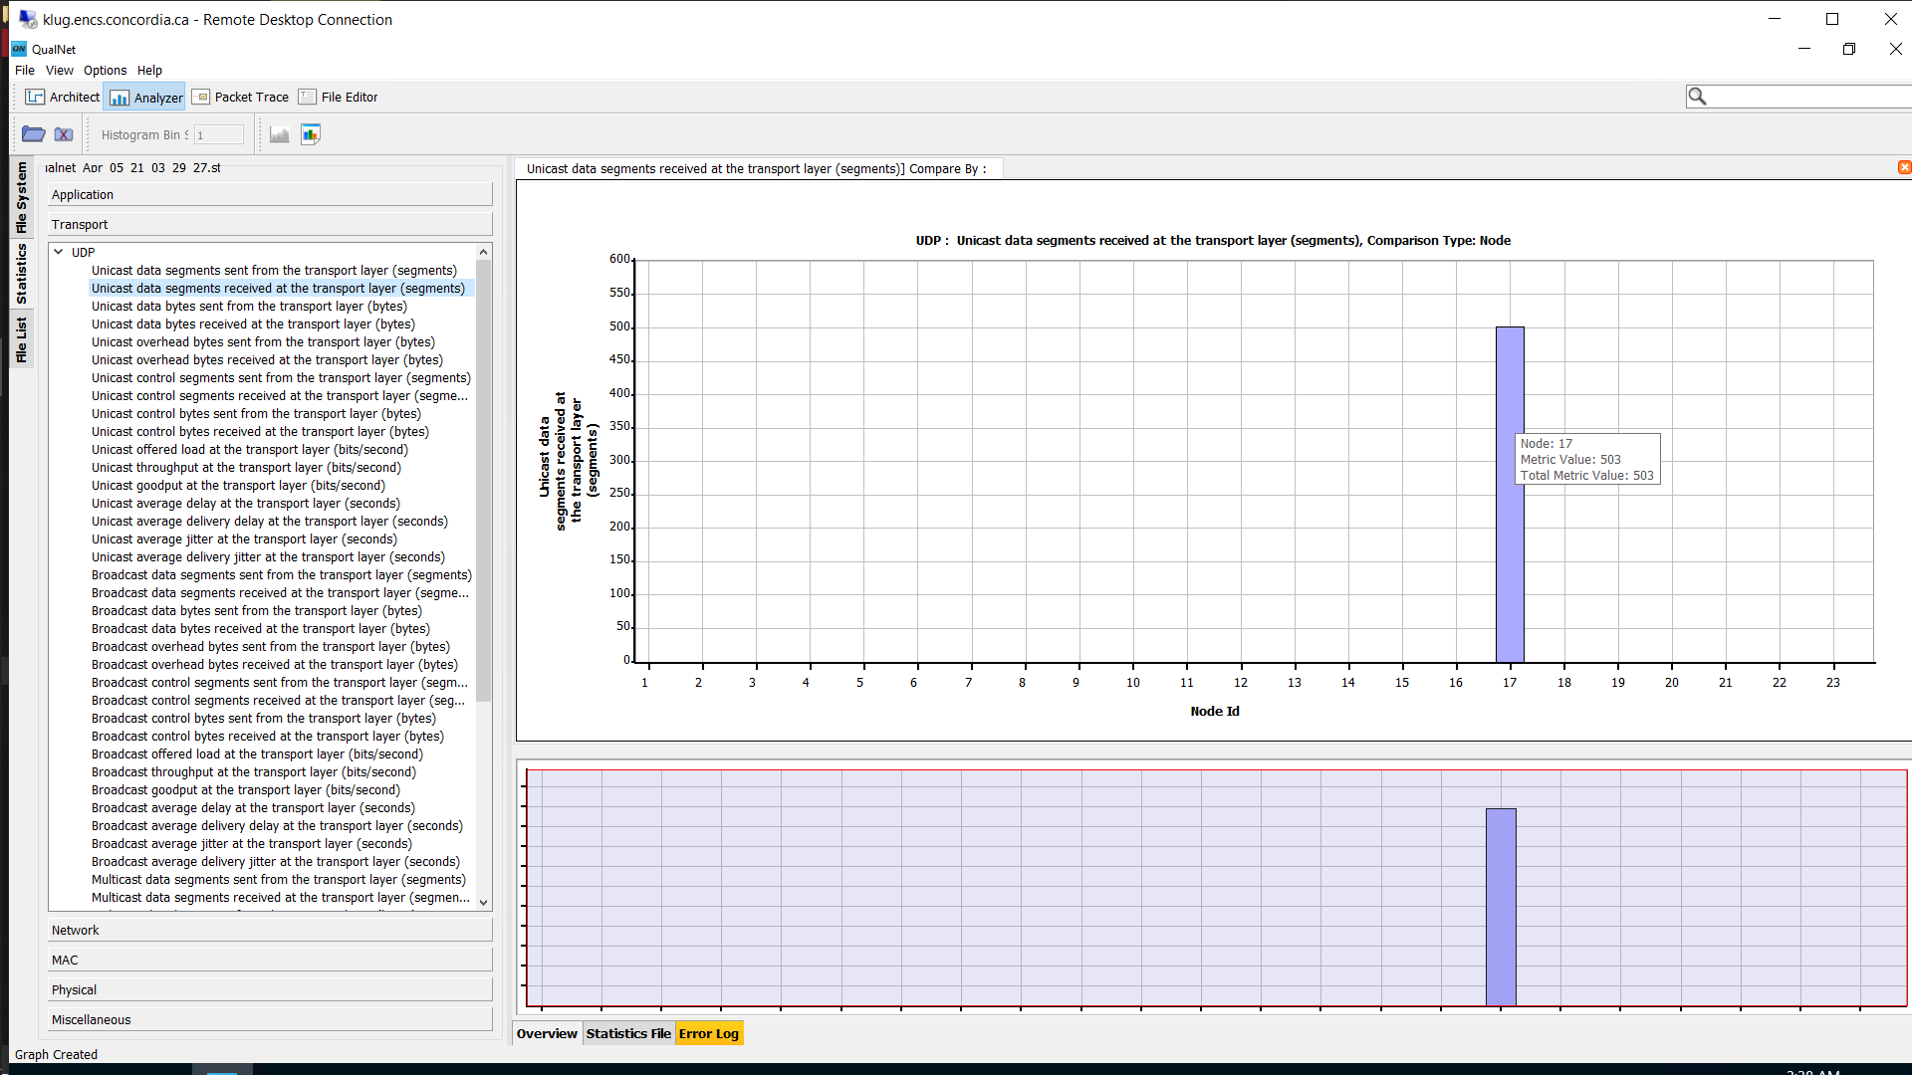

Fig 8: UDP packets to application

TCP:

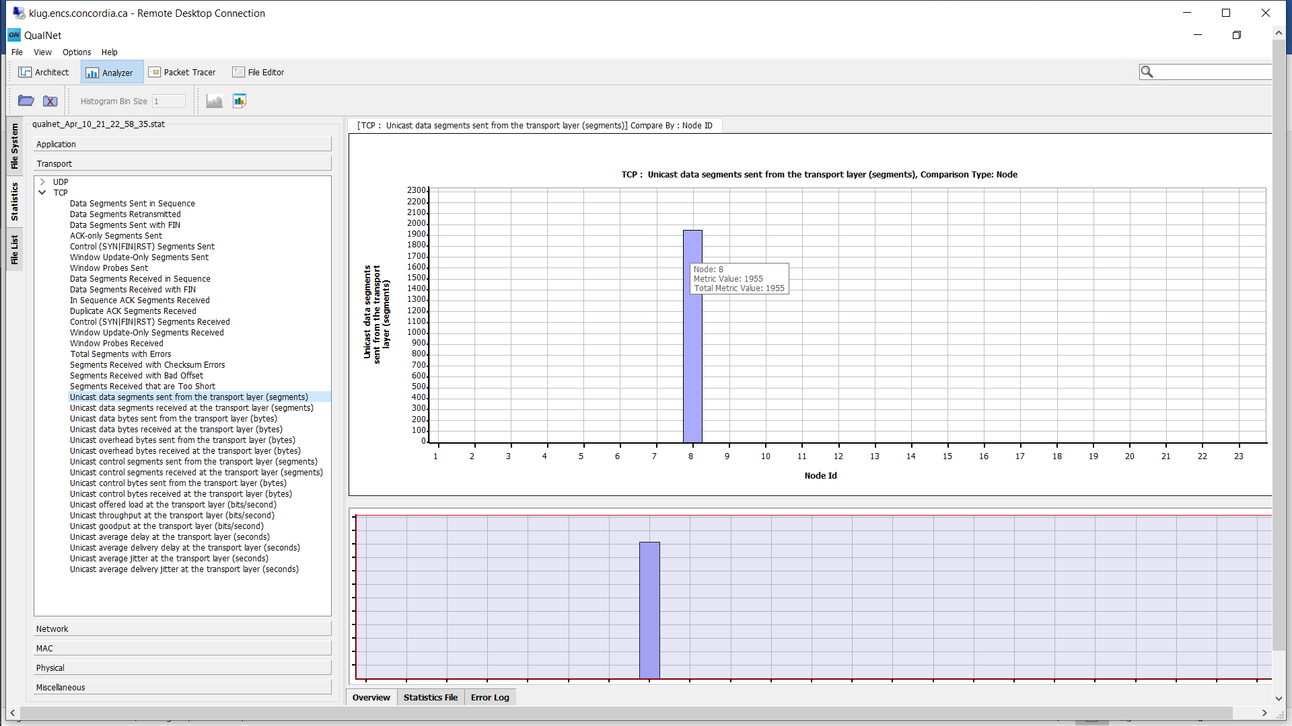

Fig 9: Data packets sent

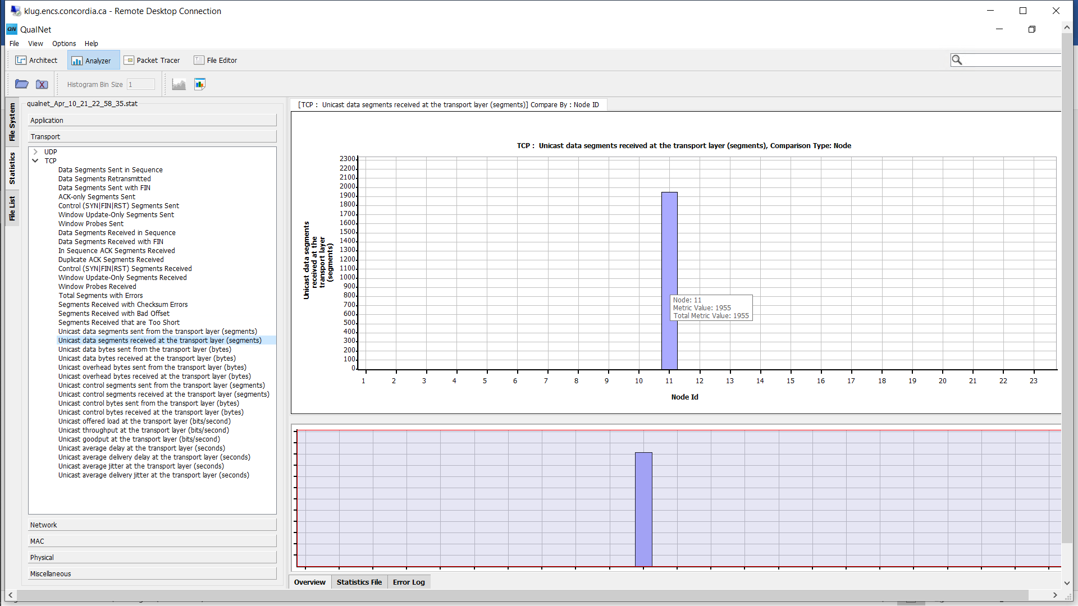

Fig 10: Data packets received

MAC layer UDP:

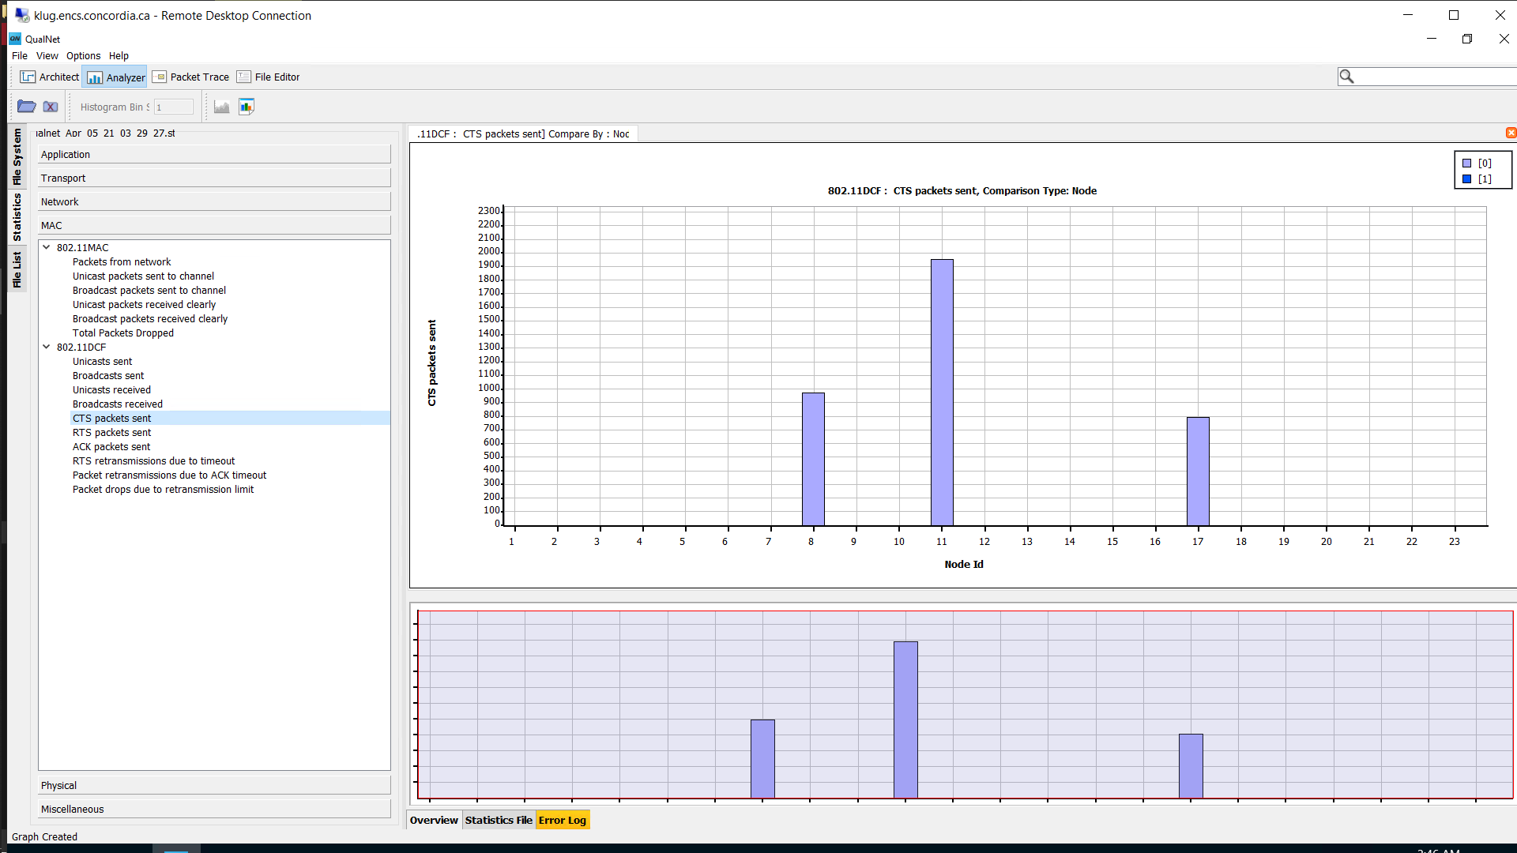

Fig 11: CTS packets sent

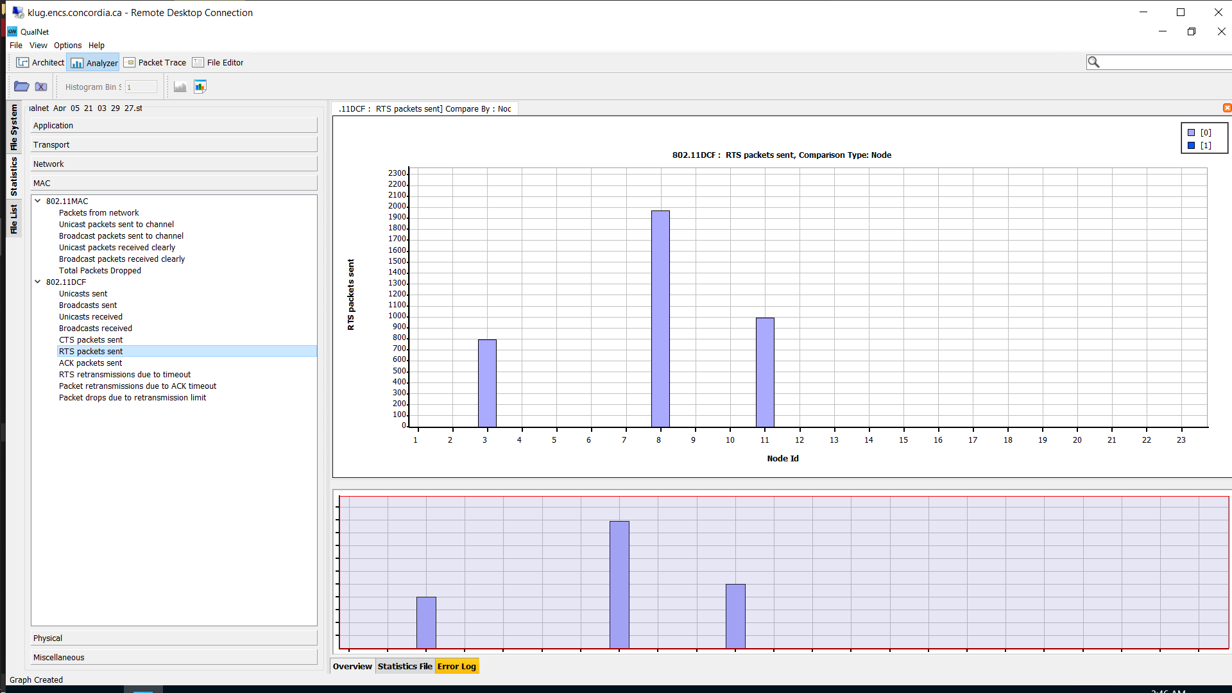

Fig 12: RTS packets sent

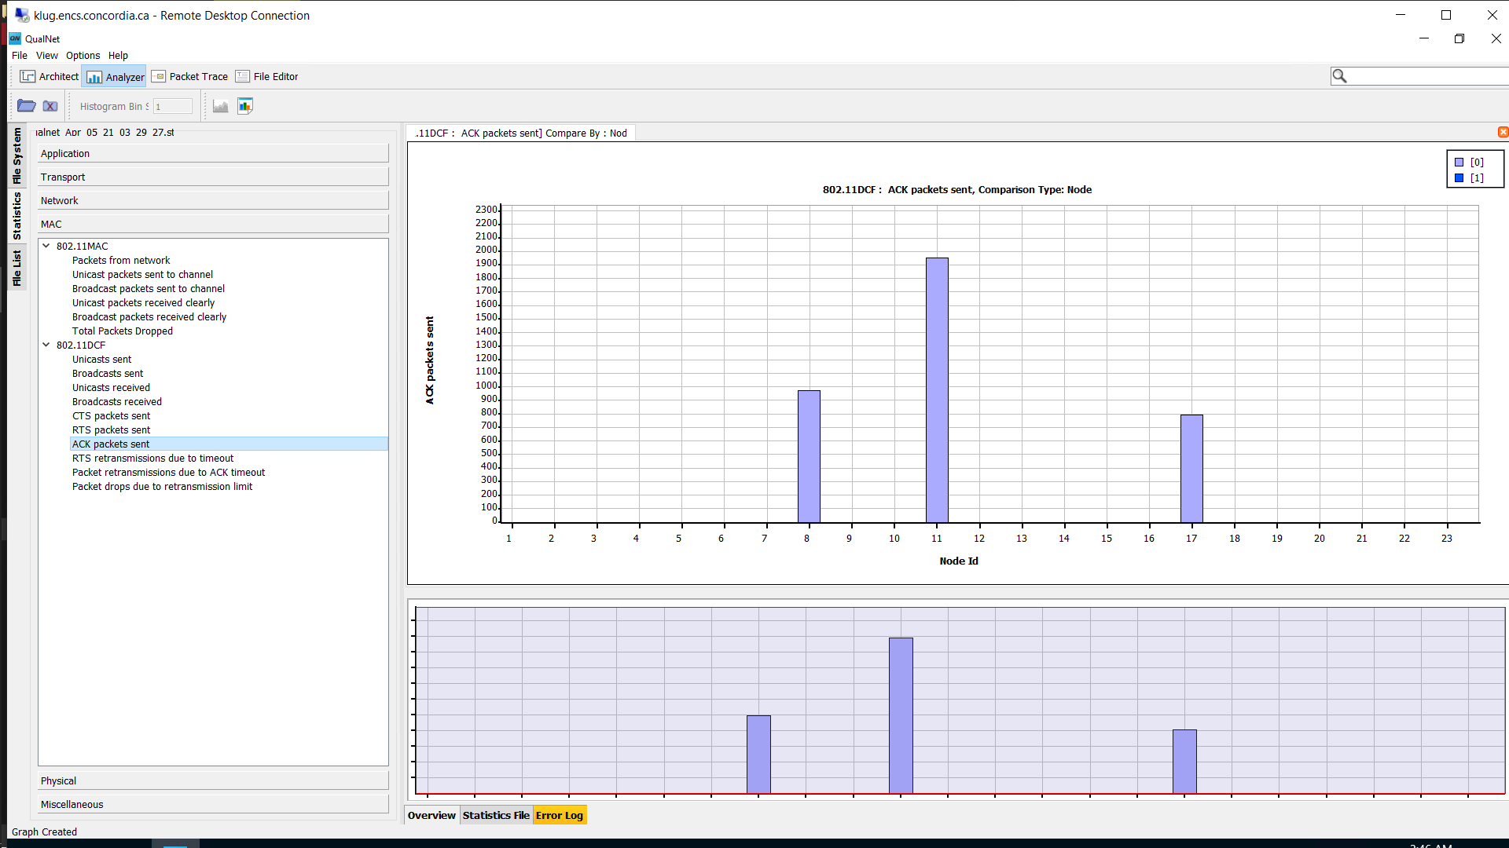

Fig 13: ACK packets sent

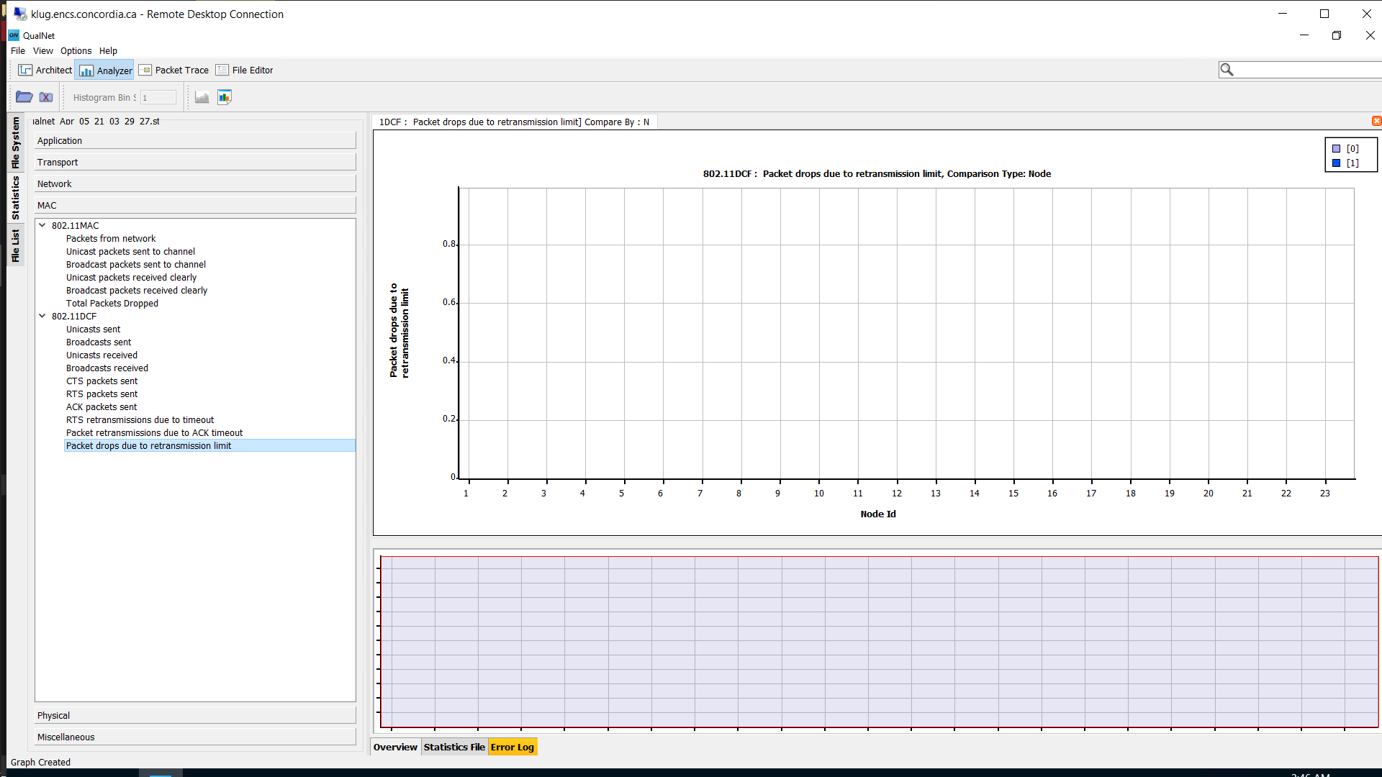

Fig 14: Packets dropped due to retransmission

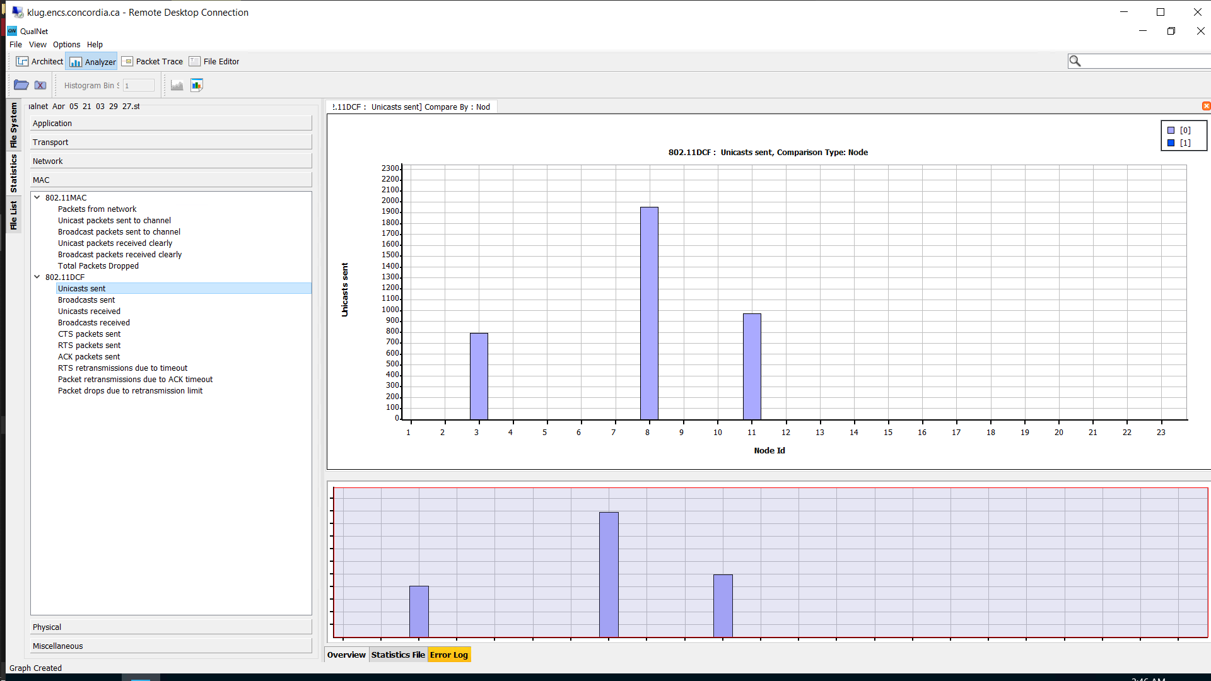

Fig 15: Unicast Sent

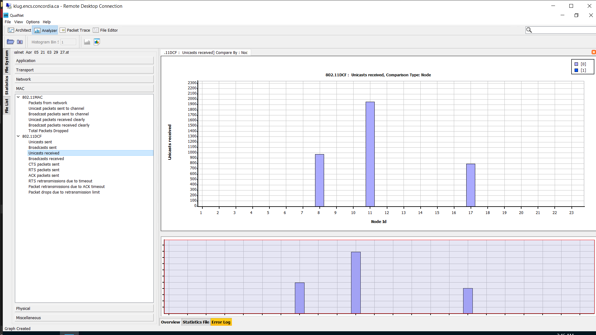

Fig 16: Unicast Received

|  |  |  |  |  |  |  |
| --- | --- | --- | --- | --- | --- | --- |
| **MAC LAYER** | **UDP NODES** | | **TCP NODES** | | **Router** | |
| **CLIENT**  **Node 3** | **SERVER**  **Node 17** | **CLIENT**  **Node 8** | **SERVER**  **Node 11** | **Node 21** | **Node 22** |
| **1. UNICAST PACKET SENT** | 799 | 0 | 1958 | 980 | 0+799=799 | 1958+980=2938 |
| **2. UNICAST**  **PACKETS RECEIVED** | 0 | 799 | 980 | 1958 | 799+0=799 | 1958+980=2938 |
| **3. PACKETS**  **DROPPED DUE TO RETRANSMISSION** | 0 | 0 | 0 | 0 | 0+0 | 0+0 |
| 1. **RTS** 2. **CTS** 3. **ACK** | 799  0  0 | 0  799  799 | 1975  980  980 | 995  1958  1958 | 0+799=799  799+0=799  799+0=799 | 1975+995 = 2970  799+980 =1779  799+980 =1779 |
| **7. RTS RETRANSMISSIONS**  **DUE TO TIME OUT** | 0 | 0 | 17 | 15 | 0+0 | 17+15 =32 |

UDP (NODE 3 & NODE 17):

1. Node 3 in subnet A is connect to the node 17 in subnet D through an UDP (Traffic Gen) connection
2. **In UDP, The Packets are not transmitted directly but are done via a router,** this is explained by observing the packets i.e., 799 unicast packets are sent through the client-side and the same is received at the server-side and the same has been mediated by the router Node 21.
3. The RTS has sent 799 packets and both the CTS & ACK also transmits the same number of packets i.e., 799 but through Node 21.

TCP (NODE 8 & NODE 11)

1. The **TCP network doesn’t have any loss of data when compared to UDP** and as a reliable stream delivery system
2. This TCP network transfers the data in the correct order using this reliable SDS (stream delivery system). This reliability is provided using the positive ACK technique which also includes the retransmission of packets.
3. In this technique the receiver has to respond to the sender with an acknowledgement message once it receives the data.
4. There is also a timer to retrieve the data or just to acknowledge in case of corrupted data or packet loss, also this whole process is monitored and recorded by the sender

Conclusion:

From the above analysis, we can come to a conclusion that the **UDP network is faster when compared to TCP** and also there was no packet drop during the process. Finally, the packets were totally transmitted through the nodes and router.

**SCENARIO B**

The given scenario simulation contains the following info:

1. Four wireless subnetworks named as A, B, C, D each attached with at least five nodes which should be randomly placed.
2. All the nodes located in the same subnetwork will be able to hear each other’s transmissions.
3. The neighbouring subnetworks should be connected through the help of routers in the following manner A⬄B, B⬄C, C⬄D.
4. Should use only IEEE 802.11 as the MAC protocol & IPv4 as the network protocol.
5. Multiple UDP connection should be given between nodes present in different subnetworks.
6. Node 1 in subnet A and Node 9 in subnet B are connected through a UDP connection
7. Node 11 in subnet B and Node 2 in subnet C are connected through a UDP connection
8. Node 8 in subnet C and Node 5 in subnet D are connected through a UDP connection
9. Node 7 in subnet D and Node 21 in subnet A are connected through a UDP connection
10. Node 16 acts as a router between subnet A&B
11. Node 23 acts as a router between subnets B&C
12. Node 17 acts as a router between subnets C&D

**Network Model:**

Table 2: IP addresses of Subnets and Routers for Scenario B

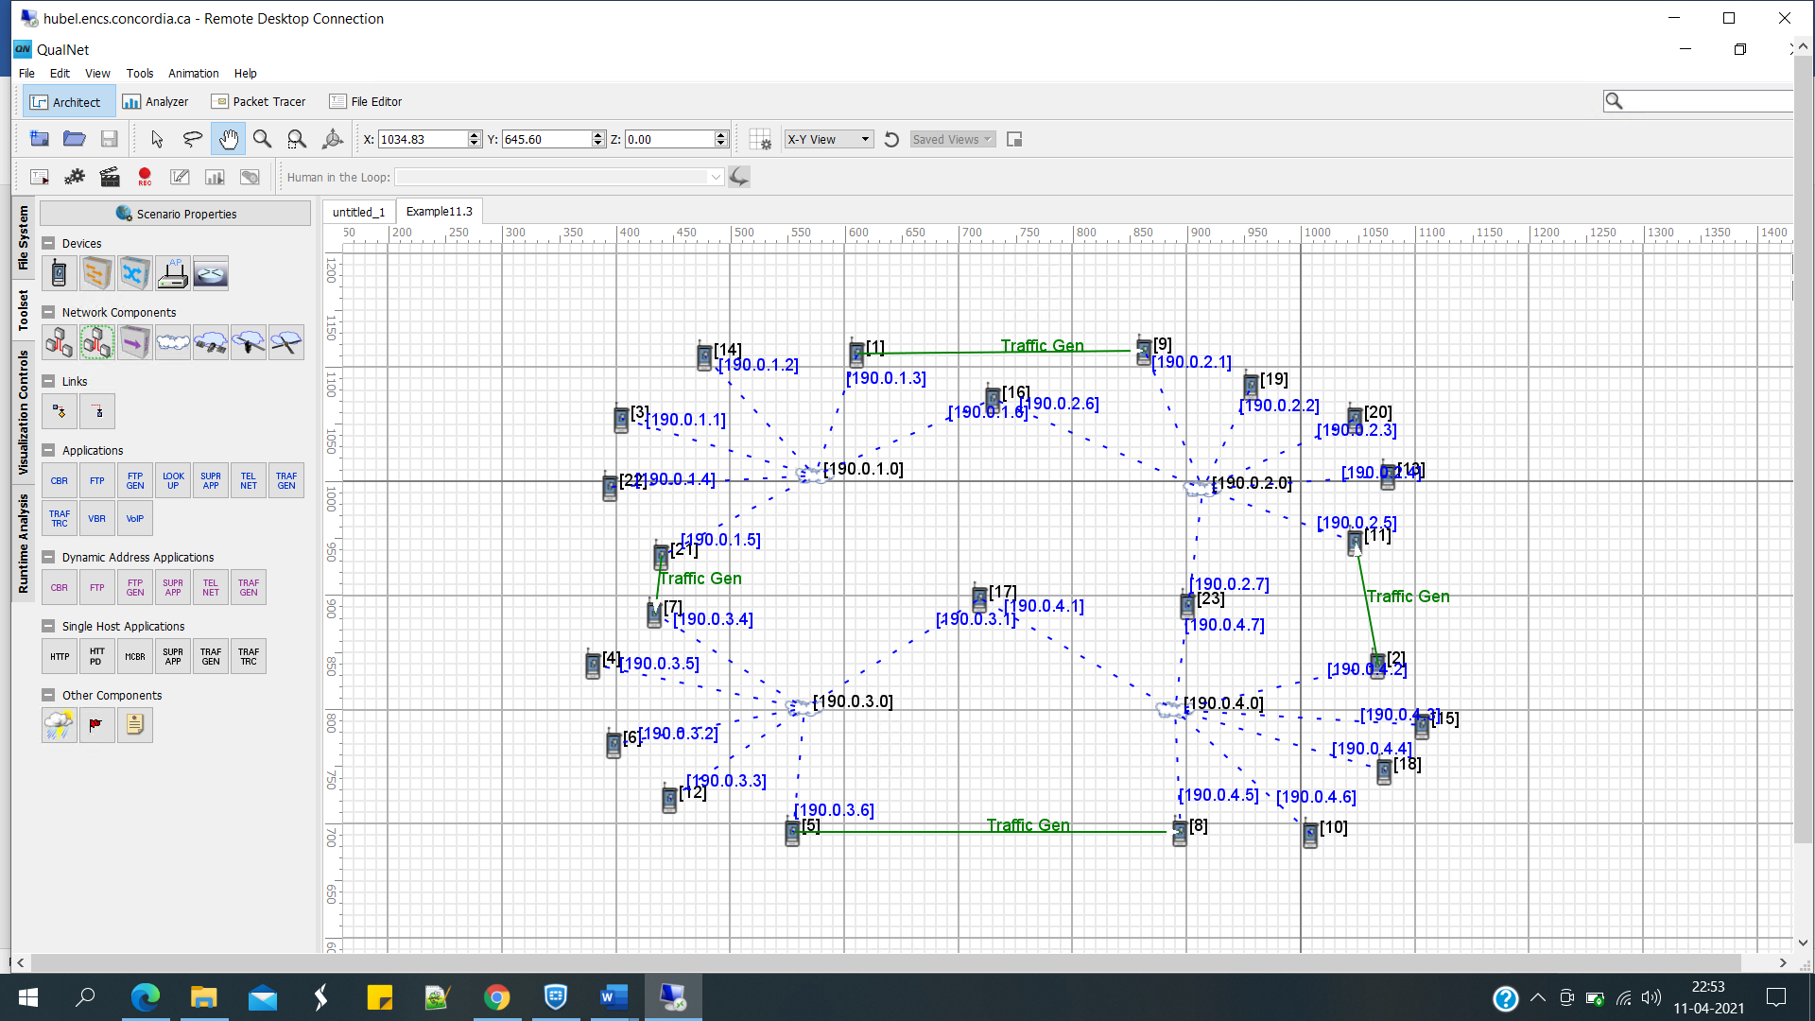

Fig 17: Network Model for Scenario B

|  |  |  |  |  |  |  |  |  |  |
| --- | --- | --- | --- | --- | --- | --- | --- | --- | --- |
| **Subnet A** | | **Subnet B** | | **Subnet C** | | **Subnet D** | | **Routers** | |
| **Nodes** | **IP address** | **Nodes** | **IP address** | **Nodes** | **IP address** | **Nodes** | **IP address** | **Nodes** | **IP address** |
| 1 | 190.0.1.3 | 9 | 190.0.2.1 | 2 | 190.0.4.2 | 7 | 190.0.3.4 | 16 | 190.0.1.6 |
| 14 | 190.0.1.2 | 19 | 190.0.2.2 | 15 | 190.0.4.3 | 4 | 190.0.3.5 | 16 | 190.0.2.6 |
| 3 | 190.0.1.1 | 20 | 190.0.2.3 | 18 | 190.0.4.4 | 6 | 190.0.3.2 | 23 | 190.0.2.7 |
| 22 | 190.0.1.4 | 13 | 190.0.2.4 | 10 | 190.0.4.6 | 12 | 190.0.3.3 | 23 | 190.0.4.7 |
| 21 | 190.0.1.5 | 11 | 190.0.2.5 | 8 | 190.0.4.5 | 5 | 190.0.3.6 | 17 | 190.0.3.1 |
|  |  |  |  |  |  |  |  | 17 | 190.0.4.1 |

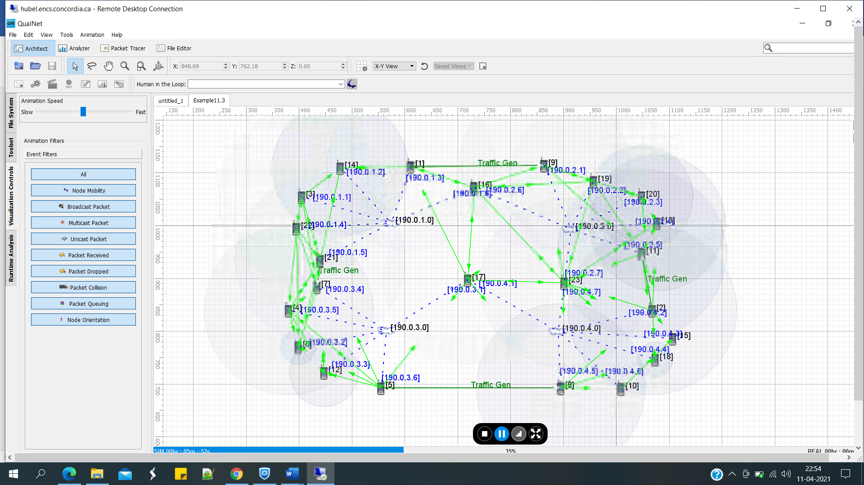

Fig 18: Network Simulation of Scenario B

**Simulation Results**:

Considering the UDP Connection node 1 from Subnet A and node 9 from Subnet B, recordings for Without Fading and With Fading are collected at Mean Interval of 0.01s, 0.04s and 0.06s.

Average UDP Packet Delay Without Fading and With Fading:

|  |  |  |
| --- | --- | --- |
| **Average UDP Packet Delay Without Fading and With Fading** | | |
| Duration | Without Fading | With Fading |
| 0.01 | 2.87173 | 0.851062 |
| 0.04 | 0.018044 | 0.025285 |
| 0.06 | 0.01502 | 0.019326 |

Fig 19: Average UDP Packet Delay

UDP Client Throughput:

|  |  |  |
| --- | --- | --- |
| **UDP Client Throughput Without Fading and With Fading** | | |
| Duration | Without Fading | With Fading |
| 0.01 | 1.68274e+06 | 1.68274e+06 |
| 0.04 | 472202 | 472202 |
| 0.06 | 316212 | 316212 |

Fig 20: UDP Client Throughput

UDP Server Throughput:

|  |  |  |
| --- | --- | --- |
| **UDP Server Throughput Without Fading and With Fading** | | |
| Duration | Without Fading | With Fading |
| 0.01 | 243281 | 1.09627e+06 |
| 0.04 | 472055 | 472015 |
| 0.06 | 315965 | 315873 |

Fig 21: UDP Server Throughput

Conclusion:

Average UDP Packet Delay, as shown in Fig 19, decreases for both With Fading and Without Fading. The delay is higher for With Fading than Without Fading as UDP is a non-reliable, best effort protocol.

UDP Client Throughput, as shown in Fig 20, decreases over the time. Client Offered Load remains constant for With Fading and Without Fading.

UDP Server Throughput, as shown in Fig 21, decreases over the time. For Without Fading, it reaches a peak and then drops, but for With Fading it is decreasing over the time.